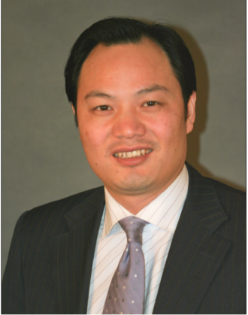
罗响博士 简介（Bio of Dr. Luo Xiang, Roy）

Dr. Xiang Luo (Roy) has over 20 years of outstanding leadership, rich international experience and local implementation capability as senior positions in the United Nations and international organizations. He is current acting as the co-chair of Social Impact Investment & Procurement Foundation (SIIP), a platform for special project fund-raising, impact investing, sustainable procurement, global partnerships and systemic solutions for sustainable development within the framework of the UN Sustainable Development Agenda.

Since 2014 to 2019, he served as country director of United Nations Office for Project Services (UNOPS)-China, leading the promotion of international cooperation with the governments, industrial partners and countries along the Belt and Road in major sectors (agriculture & food security, Bioscience & health-care, Global Innovation & digitalize economy), sustainable procurement, impact investment and other SDG relevant . He was responsible for overall management from strategic planning, fund-raising, project implementation, government and private partnership development, capacity building, public advocacy, risk management and performance evaluation. Prior to that, he was responsible for strategic planning, project implementation, and integrating platform of international resource mobilization in the United Nations Industrial Development Organization (UNIDO-ITPO) and other international economic development agencies, covering dozens of projects in life sciences, health-care, clean energy, advanced manufacturing, IOT and service outsourcing. He led the leading private equity funds and government partnerships to form over 1billion USD in special industry development funds and 100 million USD in global innovation funds.

Mr. Luo holds a PhD on business administration, and also served as a mentor for youth entrepreneur at Massachusetts Institute of Technology (MIT-CHIEF), a core expert for WWF China's Climate Initiative, and a securities trust mentor at the Postdoctoral Station of Southwest University of Finance and Economics. For his outstanding achievements in promoting the "global digital economy", he was awarded the special award of "Top Ten Leaders of China's Smart Economy 2020" by the Economic Daily Group.

罗响博士拥有超过 20 年在联合国及国际机构担任高级官员的卓越领导力、丰富的国际工作经验与本地化执行能力，现任社会影响力投资与采购基金会（SIIP）联席主席，系在联合国可持续发展议程框架下为支持实现可持续发展目标（SDG）提供特别项目筹款、社会影响力投资、可持续采购及项目管理等伙伴提供系统解决方案。

自 2014 -2019，任职联合国项目事务署（UNOPS）中国主任兼协调一带一路项目，领导推动与中国政府及一带一路沿线国家在重大项目管理（食品安全、医疗健康、数字经济），全球公共采购，社会影响力投资及科技创新等领域国际合作，负责从战略规划、项目筹资与管理、政府及私营伙伴关系、团队能力建设、公共宣传、风险管理及绩效评估等全局统筹管理。之前，曾长期在联合国工业发展组织与其他国际经济开发机构负责产业集群战略规划、项目方案实施、国际资金、贸易及技术等资源与渠道整合, 涉及生命科技、医疗健康、清洁能源、先进制造业，互联网金融及服务外包等诸多产业领域的数十个项目管理。期间曾牵头多支国际知名私募股权基金及政府合作，组建超过十亿美元的专项产业发展基金及一亿美元的全球创新基金。

罗先生拥有工商管理博士学位，亦曾兼任美国麻省理工学院（MIT-CHIEF）创业投资指导，世界自然基金会（WWF）中国区气候创行计划核心专家，西南财经大学博士后流动站证券信托导师，因推动“全球数字经济”突出成就，被《经济日报集团-杂志社》评为“2020 中国智慧经济十大领军人物”特别奖项。

